You’re invited!
to the
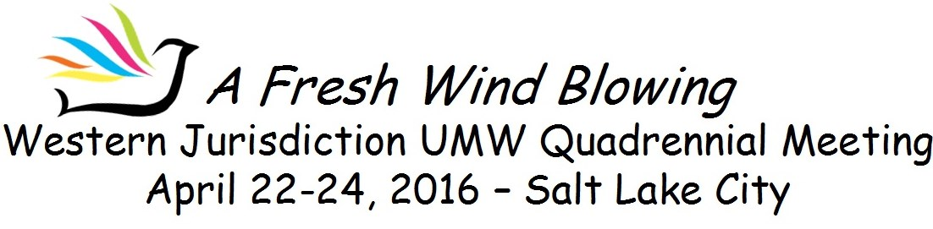
Hilton Salt Lake City Center Hotel

Rocky Mountain Conference and the Utah Western Colorado District are excited that Salt Lake City was chosen as the location for our Quadrennial Meeting. People have been asking, “Why Salt Lake? How is a location chosen?” First, the Jurisdiction Team prays… researches…and gathers information ….and talks. We discovered that we had not had a Quadrennial Meeting in this conference for a long time, and we do like to move about from conference to conference. Then, we looked at airports which are hubs, which most of our people can fly into directly, with less cost. Then we looked at altitude, and Denver was crossed off the list because of altitude. Salt Lake City looked very promising.

The next step was to take the Leadership Team to Salt Lake City for a site visit. We found the city to have good public transit, and the airport not too far from downtown. We checked out four hotels and found the Hilton Salt Lake City Center Hotel would work very well for our meetings, with the entire second floor dedicated to our activities. Room rates are reasonable, the hotel is very accessible, and you will see that it is a “green” hotel.
Volunteer at UMCOR West Depot in Salt Lake City!
Contact Brain Diggs, Director of UMCOR West, at bdiggs@umcor.org or 801 973-7250 to reserve a week or a few days to work at the Depot before or after the Quadrennial meeting. Make your plans soon, as there is a limit on how many can work at one time. Tell Brian that you will be at UMW Quadrennial Meeting as he has reserved spaces for us. Read more about UMCOR at www.UMCOR.org.

Of course the main reason you’ll want to come to Salt Lake is for our Quadrennial Meeting! The Leadership Team has been energized by our theme of “A Fresh Wind Blowing” as we look at scripture and the ways that the wind of the Holy Spirit moves and leads us. We have been working on speakers, tours, worship, workshops, and of course the whole process of elections for Directors for National Office. But beyond the meeting, there is much to do in Salt Lake. UMCOR West Depot is there, and some may want to come for the week before or after our meeting to work at the Depot. We’ll be offering tours of the Depot as well. Salt Lake is also the home of Crossroads Urban Center, one of our National Mission Institutions.

And then…. I could mention that the hotel is only a couple of blocks away from the big City Creek Center shopping mall. The Mormon Tabernacle Choir practices on Thursday evening, and there is no admission charge to listen to them. For those who like genealogy, the Family History Center, located downtown, is the largest of its kind in the world. There’s a zoo, a planetarium, a water park, pioneer museums, a natural history museum, an arboretum, and so much more. If you want to get out of the city, Utah has five stunningly beautiful National Parks, ten National Monuments and Recreation Areas, and 2,200miles of Scenic Byways. The Olympic Winter Games were held in Utah ten years ago and the Utah Olympic Park is not far from Salt Lake City. Utah is home to five distinct American Indian cultures, and is also the center of Mormon Heritage.

So, put this on your calendar! Salt Lake City, April 22-24, 2016. We always look forward to a great time as we come together as United Methodist Women!
by Margaret Hotze, President, Western Jurisdiction Leadership Team

