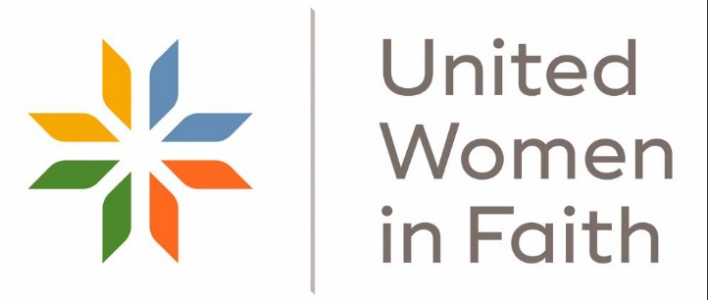

NEW YORK, N.Y., Mar. 2, 2022: United Methodist Women is now United Women in Faith! The move is part of a refreshing of the organization that includes a new logo and an array of new and improved programs to nurture current members and welcome new women to join to put their love in action on behalf of women, children, and youth.
The organization announced the new operating name in the March-April edition of response, its bimonthly magazine for members, and is launching the rebrand with a new website and Face Book event March 3 at 1 pm ET.
The changes are designed to address the different needs and life stages of current members and new women and expand options for membership and engagement. The new name also aims to welcome current members whose local churches may choose to disaffiliate from The United Methodist Church as well as women of other faith traditions who want to join.
New and innovative programs will be rolled out throughout 2022, including:
- A new, easier to navigate website
- A new “All-Access” National Membership Option
- Soul Care Retreats
- Innovations to Mission u, the organization’s longtime spiritual growth and transformative education program.
The organization remains incorporated in New York as United Methodist Women and is doing business as United Women in Faith.
United Women in Faith seeks to connect and nurture women through Christian spiritual formation, leadership development, creative fellowship, and education so that they can inspire, influence and impact local and global communities.

